

AMERICAN INTERNATIONAL UNIVERSITY BANGLADESH

FACULTY OF SCIENCE AND TECHNOLOGY

Course: Data Warehousing And Data Mining [ C ]

REPORT ON
Cancer prediction using K-NN Algorithm
SUPERVISED BY
DR. AKINUL ISLAM JONY
Associate Professor & Head (UG)
Faculty Of Science & Technology

Submitted By

SHOAIB TAHMIN RAFIN 19-41662-3
RAHATUL AJEM KHAN 19-41753-3
TALUT MAHAMD DEEP 20-42565-1

Project Overview:
This project involves building an interactive dashboard using Shiny, which is based on web scraping data. The dashboard will display information about movies, such as ratings, years, and gross earnings. The dashboard has four tabs: Movies by Rating, Movies by Year, Movie Details, and Highest Voted Movies. The Movies by Rating tab contains a slider input that allows the user to filter movies based on rating. The data is filtered using the filter() function, and the resulting data is displayed in a histogram using ggplot2.The Movies by Year tab contains a slider input that allows the user to filter movies based on the year they were released. The data is filtered using the filter() function, and the resulting data is displayed in a histogram using ggplot2.The Movie Details tab allows the user to search for specific movies based on the movie name and year of release. The data is filtered using the filter() function, and the resulting data is displayed in a table using renderTable().The Highest Voted Movies tab displays the top ten highest-voted movies. The data is sorted using the arrange() function, and the resulting data is displayed in a bar chart using ggplot2.The project also involves web scraping data from IMDb using the rvest package. The data is stored in a CSV file and imported into R using the read.csv() function. The data is then cleaned, and summary statistics are calculated.

Overall, this project involves using Shiny to create an interactive dashboard that displays movie data and using web scraping to extract data from IMDb.
KNN Algorithm Libraries:
The k-nearest neighbors (k-NN) algorithm is implemented in R using the “class” package and other labraries are use for
corrplot: Correlation matrix visualization.
caret: Unified machine learning interface.
dplyr: Data manipulation and transformation.
ggplot2: Advanced graphics and visualization.

Data preprocessing:
Importing data:
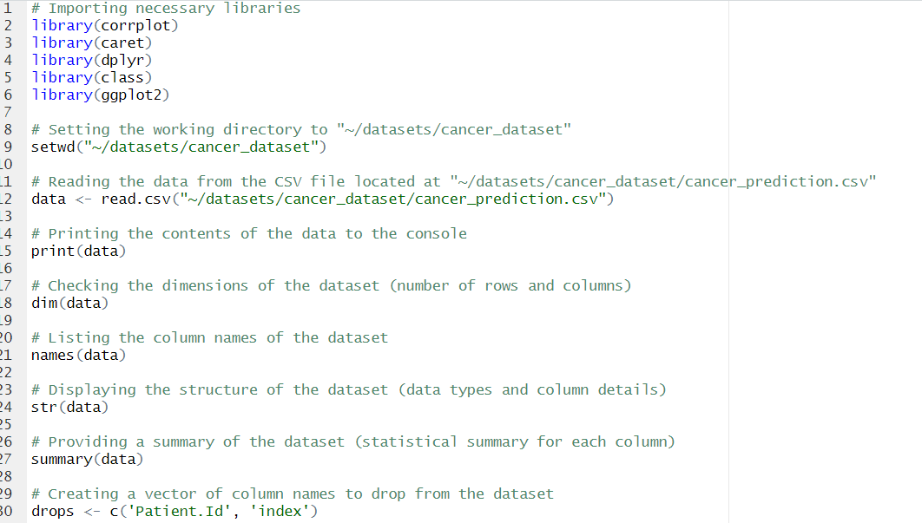

Data cleaning:
Finding missing and null values:
Removing null and missing values
Removing the specified columnns

Checking the dataset after cleaning:
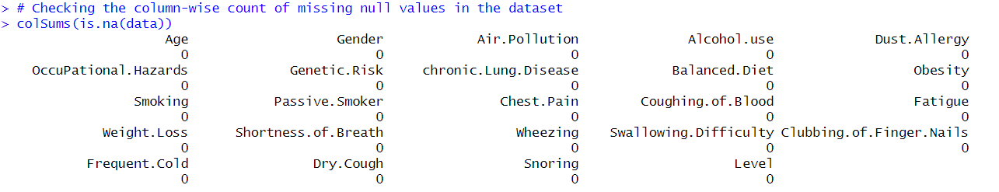
Checking the dataset after normalization:
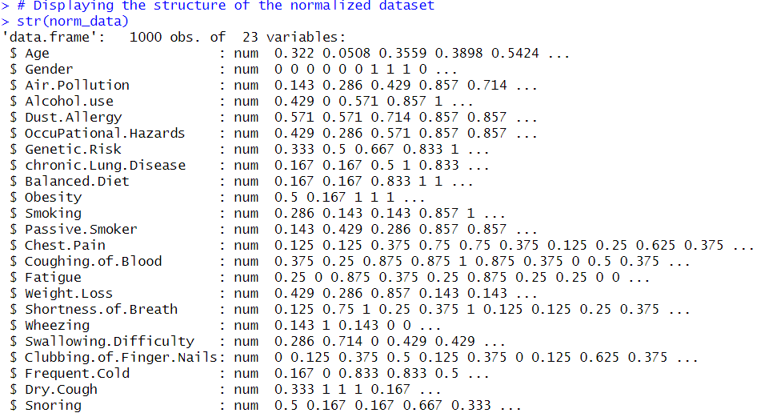

descriptive statistics:
summary statistics:
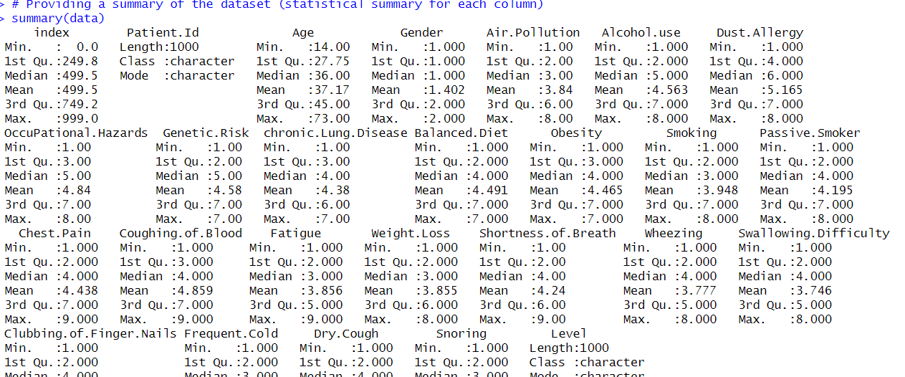
Different K value:
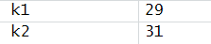
Comparison of different K value

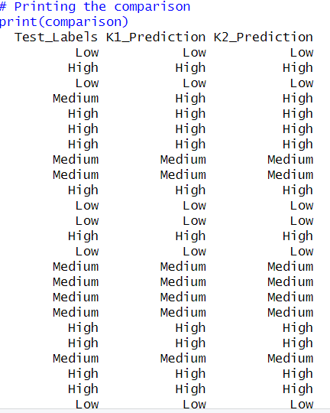
Confusion Matrix
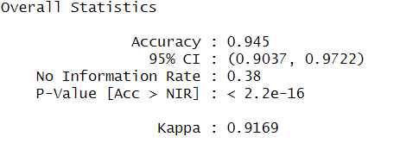
Data visualization:
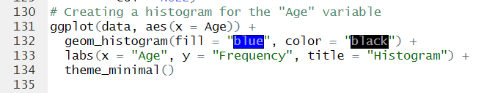

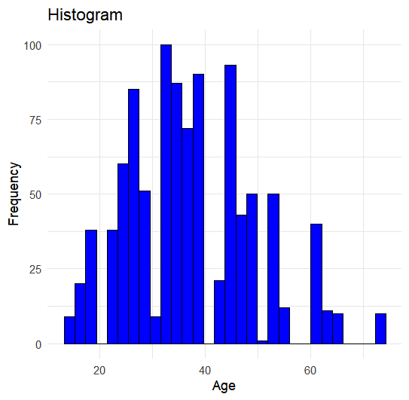
Discussion and Conclusion:
In this project, we used the k-nearest neighbors (k-NN) algorithm in R to build a cancer prediction model using the "cancer_prediction.csv" dataset. We utilized several libraries, including `corrplot`, `caret`, `dplyr`, `class`, and `ggplot2`, to perform various tasks in our project.
The `corrplot` library was used for visualizing the correlation matrix. This helped us understand the relationships between different features and identify any strong correlations that might influence our model's performance.
The `caret` library provided a unified interface for machine learning tasks. We used it to handle data preprocessing, feature selection, model training, and evaluation. This allowed us to streamline the process and ensure consistency in our analyses.
With the help of the `dplyr` library, we performed data manipulation and transformation tasks. This included filtering, selecting, arranging, grouping, and summarizing the data as needed for our analysis. The library's functions made these operations efficient and easy to implement.
The `class` library played a crucial role in implementing the k-NN algorithm. We utilized the `knn()` function to train our model using different values of k (specifically, 29 and 31). The k parameter determines the number of nearest neighbors considered for making predictions.
To evaluate the performance of our model, we used a confusion matrix. A confusion matrix provides insights into the accuracy and misclassification of our predictions. It allows us to analyze true positives, true negatives, false positives, and false negatives, which helps assess the model's effectiveness.
In conclusion, this project aimed to develop a cancer prediction model using the k-NN algorithm in R. We utilized various libraries for correlation visualization, machine learning tasks, data manipulation, and visualization. By trying different values of k and evaluating our model's performance using a confusion matrix, we gained insights into the accuracy and reliability of our predictions.
It's important to note that the specific results and findings of the project are not mentioned in the provided code. The actual model performance, including accuracy, precision, recall, and other evaluation metrics, along with the interpretation of the results, would need to be discussed based on the executed code and the specific characteristics of the dataset.

